Project Design Phase
Solution Architecture

Date | 15 February 2026
Team ID | LTVIP2026TMIDS65542
Project Name | AutoSage App Using Gemini Flash
Maximum Marks | 4 Marks

Solution Architecture:
Solution architecture for AutoSage bridges the gap between the problem of unstructured vehicle information and the AI-based technological solution.
The architecture is designed to:
- Find the best AI-based solution for vehicle analysis and comparison.
- Define the structure and interaction between UI, backend logic, and AI services.
- Clearly describe how vehicle images are processed and analyzed.
- Provide specifications for deployment and system management.

Solution Architecture Diagram:

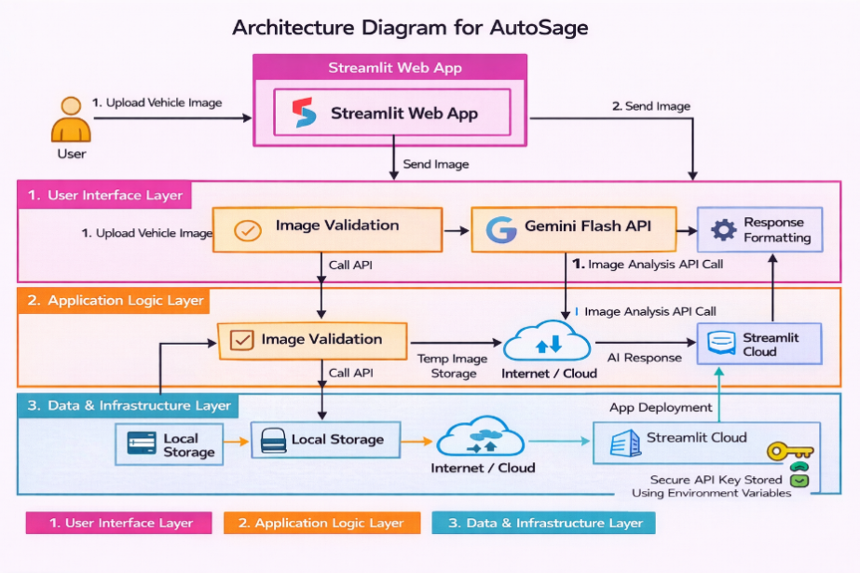

Figure 1 – Architecture Diagram for AutoSage app

